*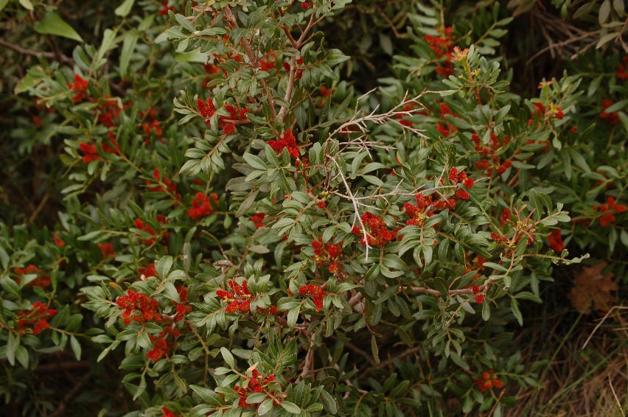Pistacia lentiscus*

*Pisctacia lentiscus*, commonly known as ‘mastic tree’, that is found along the Southern Mediterranean coast, particularly the Island of Chios, Greece.[[1]](http://www.gbif.org/species/3190583) Growing to 5m by 3m at a slow rate, this evergreen Shrub produces a ‘sweet liquourice-flavoured resin’ called mastic. This mastic can be used in confectionary such as ‘Turkish Delight’ and liqueurs such as ‘mastiche’.[[2]](http://www.pfaf.org/user/Plant.aspx?LatinName=Pistacia+lentiscus)

Pistacia lentiscus - captured by KoS [[4]](https://commons.wikimedia.org/wiki/Pistacia_lentiscus#/media/File:Pistacia_lentiscus_Toulon_France.jpg)

Mastic resin has also been traditionally and contemporarily used in herbal medicines to treat a variety of ailments from diarrhoea to ulcers, ringworm and temporary tooth fillings.[[2]](http://www.pfaf.org/user/Plant.aspx?LatinName=Pistacia+lentiscus) Mastic has been used since at least biblical times, as shown in Genesis 37:25 where it is referred to as a styptic substance (e.g. haemostatic agent) and Mediterranean countries are known to have been using the gum as a traditional remedy for centuries.[[3]](https://www.lens.org/images/patent/EP/1501527/B1/EP_1501527_B1.pdf) Other uses for mastic gum include toothpaste and essential oils.[[2]](http://www.pfaf.org/user/Plant.aspx?LatinName=Pistacia+lentiscus)

*Pisctacia lentiscus* grows well in most soils but prefers a well-drained to dry sandy or stony alkaline soil in a position in the hot sun. It can also grow in very alkaline conditions.